WOMEN TECHSTERS FELLOWS 2021/GROUP 8

**SHERO AGENCY FINAL REPORT**

**“PROVIDING TECH SOLUTIONS FOR GENDER BASED VIOLENCE”**

Data Science Analytics: zeroing in on violence against women & girls Vis-a’-Vis Covid-19 Pandemic lockdowns

**2021**

**Table of Contents**

**Executive Summary** 2

**Chapter 1** 3

**Business Understanding** 3

**1.1 Background** 3

**1.2 Partnership with Global Objectives** 6

**1.3 Hypothesis** 6

**1.4 Problem statement** 6

**1.5 Comprehensive Project objective:** 6

**1.6 Idea Breakdown** 7

**1.7 Project lifecycle** 9

**1.8 Project Delimitation** 10

**1.9 Project Research Limitations** 10

**Chapter 2** 11

**Project Methodology** 11

**2.1 Research approach** 11

**2.2 Research design / strategy** 11

**2.3 Research methods** 11

**Chapter 3** 12

**Data Analysis, Interpretation & Discussion of Major Findings** 12

**3.1 Statistical (or textual) analysis techniques used** 12

The below packages are pre- installed by default on Anaconda, since Jupyter notebook works on anaconda and the following libraries were invoked for easy statistical analysis: 12

a. Matplotlib.pyplot as plt 12

c. Seaborn as sns 12

d. Numpy as np. 12

**3.2 Biographic data of participants** 12

**3.3 Discussion of Major Findings** 13

**3.4 Chapter Summary** 16

**Chapter 4** 17

**4.1 Application & Reporting System Visualization & Process Breakdown** 17

**4.2 Significance of the Project** 23

**4.3 Project Forecast** 23

**4.4 Recommendations** 23

**4.5 Conclusions** 24

**References** 25

**Team Breakdown & Role Allocation** 28

## **Executive Summary**

This project is a collaborative result of the quantitative and qualitative analysis of data obtained from actual victims of sexual violence to show answers to the questions:

1. Was gender-based violence still a recurring issue during the COVID 19 pandemic lockdown?
2. What kind of cases did the survivors have?
3. Is there a COVID 19 compliant channel through which future victims in Africa can access?

For anonymity, personal information was undisclosed in the raw data set used for data analysis. The countries where we currently have representation are Ghana, Egypt, Kenya, Nigeria, and South Africa.

Primary data sources analyzed showed that common cases reported had children as young as 6 years to 25 years old have faced sexual violence; while extreme cases of 3 and 6-month-old babies were recorded also. Shockingly also the oldest abused recorded was an elderly woman aged 85.

Our detailed Analytics report shows that gender-based violence still is a recurring issue even while the world is dealing with COVID 19 and its many other health and safety implications. Gender-Based Violence knew no end because of the pandemic nor the lockdown because as shown when the lockdown was in full swing (which was also the rainy season) in Nigeria, the number of recorded cases surged at least 100% from January through March 2020. There are sexual abuse, physical and psychological abuse records and we can only imagine the number of cases that could not come forward to report for fear of discrimination and stigmatization.

SHERO is an option, a way out and we have detailed the possibilities that could arise with the activation of this medium. We do encourage you to contact us to support and help drive this initiative towards making our world a much safer place for persons affected by gender-based violence. Together we can achieve this goal to make the world a safe place for women and girls, which is unilaterally an achievement of the SDG Target 5.2 Eliminate all forms of violence against women and girls.

## **Chapter 1**

# **Business Understanding**

This chapter deals with the preliminary breakdown of the business understanding element of the project, narrating the business objectives and formulating a map or outline that will guide the entire project.

## **1.1 Background**

“The outbreak of COVID-19, emerging data and reports from those on the front lines, have shown that all types of violence against women and girls, particularly domestic violence, was reported to have intensified according to the United Nations Women report which sites violence against women as the Shadow Pandemic growing amidst the COVID-19 crisis.

Facts according to UN Women 2020

* Globally, even before the COVID-19 pandemic began, 1 in 3 women experienced physical or sexual violence mostly by an intimate partner
* Emerging data showed an increase in calls to domestic violence helplines in many countries since the outbreak of COVID-19.
* Sexual harassment and other forms of violence against women continued to occur on streets, in public spaces, and online.
* Survivors were reported to have limited information and awareness about available services and limited access to support services.
* In some countries, resources and efforts were diverted from violence against women’s response to immediate COVID-19 relief.

Hayley Boxall, Anthony Morgan, and Rick Brown in their research paper also cited that Since the first case of the novel coronavirus (COVID-19) was confirmed in Australia in January 2020, both the disease and the measures implemented to limit its spread have had significant impacts on the day-to-day lives of Australians. In the past few months, there have been numerous media reports about the risks to the safety of victims of domestic violence (intimate partner violence), including concerns about an increase in violence, more complex forms of violence, and the impact of social distancing measures on the ability of victims to seek help (Morton 2020; Nancarrow 2020; Pfitzner, Fitz-Gibbon & True 2020).

Various factors have been identified as contributing to a potential increase in both the prevalence and severity of domestic violence during the COVID-19 pandemic, including:

* Victims and offenders spending more time together; increased social isolation and decreased social movement, which may restrict avenues for women to seek help;
* Increased situational stressors associated with domestic violence (e.g. financial stress and job insecurity); Statistical Bulletin 28 Australian Institute of Criminology 2
* offenders feeling out of control due to situational factors and using violence and abuse as a means of creating a sense of control; and
* increased alcohol consumption among domestic violence perpetrators (Delaney 2020; Morton 2020; Nancarrow 2020; Payne, Morgan & Piquero 2020).

There is a lack of research into the prevalence of domestic violence among Australian women since the start of the COVID-19 pandemic. Given the majority of women experiencing violence and abuse within their relationships do not engage with police or government or non-government agencies—particularly while they remain in a relationship with their abuser—this is a significant knowledge gap (ABS 2017). Relatedly, there are concerns that opportunities for women to contact and engage with domestic violence services or the police have been even more constrained during periods when social movement was restricted (Fitz-Gibbon & Meyer 2020). There are particular concerns about the safety of women experiencing coercive controlling behavior (Pfitzner, FitzGibbon & True 2020).

Africa Union Commission in their 2020 joint research paper on Gender-Based Violence in Africa during the COVID-19 Pandemic cited the following:

1. According to the Kenya National Council on Administration of Justice, Kenya has a significant spike in sexual offenses in many parts of the country. Sexual offenses such as rape and defilement have constituted more than 35% of all reported cases.12
2. In Egypt, there was a 19% increase in violence against family members linked to strict measures being implemented to limit the spread of COVID-19, according to a UN Women Egypt and Baseera survey. Amongst women surveyed from 04 to 14 April 2020, 11% of women had been exposed to violence the week before the survey.
3. A rapid assessment conducted by UN Women in Libya at the onset of the pandemic indicated that nearly half of the women surveyed feared an escalation of violence at home at the beginning of the lockdown period.
4. South Africa: Official reports show that within the first week of level 5 lockdown, South African Police Services (SAPS) received 2,320 complaints of gender-based violence, with only 148 related charges made. These statistics represent a 37% increase from the weekly average of South African GBV cases reported for 2019.16 Additionally, the GBV Command Centre in South Africa recorded a spike in gender-based violence cases reported during the lockdown from 27th March to 16th April with a total of 10,660 through phone calls, 1503 through unstructured supplementary services data (USSD) and 616 SMSs. On 16th April alone, the Centre has received 674 cases.17
5. Nigeria: reporting from 24 states across the country shows that the number of reported incidents of domestic violence spiked by 56 percent during the first two weeks of April compared with the same period in March, after lockdown measures were enacted on 31 March. In Lagos State, cases of domestic violence have surged by over 100 percent during the lockdown period (as of 14 April) compared with the number of cases reported for the entire month of March.
6. All in all 67% of women have experienced abuse which Is double the average global rate ( according to UNFPA report from March 30th, 2020 - April 5th;23 defilement cases,22 rape cases, and 2 cases of passion killings were recorded, of the 23 defilement cases, 7 were children under 13 years of age.

**The Data GAP**

As per the narration of the Africa Commission, the Data gap Data collection on the types of violence against women and girls is essential to prioritize addressing violence against women in the response to COVID-19 and recovery efforts. Gender-Based Violence in Africa during the COVID-19 Pandemic. The emerging data of the impact of COVID-19 on women and girls highlighted in this briefing may currently likely only be reflecting the worst cases. Without access to private spaces, many women will struggle to make a call or to seek help online. Moreover, the potential loss of income due to self-isolation, potential lack of information regarding which GBV services remain available, and fears of contracting the virus at service points have created multiple barriers whereby survivors of GBV may find themselves in a near-impossible situation: unable to seek support, unable to access services, unable to leave their abusers26 and with nowhere to go. Thus understanding the scale and diverse experiences of sexual and gender-based violence (SGBV) for women and girls during the COVID-19 pandemic remains paramount for all African countries. Cameroon, Kenya, Malawi, South Africa, Uganda, and Zimbabwe,27 provide examples of taking steps to improve the collection and use of violence against women data in the COVID-19 context.

Addressing the Data Gap is where our agency comes in; which will be reiterated in the proceeding project breakdown.

## **1.2 Partnership with Global Objectives**

**Our agency pledges allegiance, relevance as well as a partnership with the following United Nations Sustainable Development Goals**

* SDG 5: Achieve gender equality and empower all women and girls: Women and girls, everywhere, must have equal rights and opportunity, and be able to live free of violence and discrimination. Women’s equality and empowerment are one of the 17 Sustainable Development Goals and integral to all dimensions of inclusive and sustainable development. In short, all the SDGs depend on the achievement of Goal 5
* SDG Target 5.2 Eliminate all forms of violence against women and girls
* SDG Target 16.1 Significantly reduce all forms of violence and related death rates everywhere

## **1.3 Hypothesis**

* There are not enough reliable and safe reporting channels for intimate partner abuse
* Women have no access to information about their rights and the support they can get with issues regarding gender-based violence
* Covid-19 along with its restrictions catalyzed an increase in domestic and gender-based violence

## **1.4 Problem statement**

Regardless of the strides made globally and locally in the women’s rights liberation movements and gender affairs economically, constitutionally, and politically; Women and girls are still susceptible to violent crimes, sexual and non-sexual. The Covid-19 pandemic only exposed the degree of its severity ( a handful of women particularly in southern Africa died due to intimate partner violence) and how much there is still exceedingly more room for much to be done to actualize progressively the multi-dimensional development as well as the social welfare of women.

## **1.5 Comprehensive Project objective:**

To innovatively provide a technological solution to a social issue affecting women and girls, particularly gender-based violence and intimate partner abuse through engaging data science, analytics, and programming tools. The process is broken down into three phases

* To conduct a deductive data analysis of abused women and girls during post the enforcement of Covid-19 restrictions & lockdowns zeroing in on countries with data availability in Africa, Nigeria being the largest sample size, zooming in on Egypt, Ghana, South Africa, Kenya.
* To develop a reporting system that populates a database, collecting data in form of reports that narrates their witnessing of or experience with abuse and intimate partner violence, collecting data demographics as well as key information like mode of abuse and frequency.
* To develop an intelligent technology in the form of an application linked to the reporting system database, which not only reports imminent violence but operates as an emergency hotline and responds to a woman who expresses active and urgent distress and solicits relevant help by sending the woman’s geographical coordinates to the right authorities.

Lastly to use data collected through the reporting system for predictive analysis and report writing to sponsor preventative measures through engaging the right partners; governmental and private who are aligned with causes for women’s social issues and gender affairs

## **1.6 Idea Breakdown**

**Zeroing in on the innovative technology; what is the big idea ( SHERO Application and the reporting system interface?**

* What if we could stop the death of one woman, what if we can prevent perverse injuries that scar her for life and cause her to be self-conscious and battle with self-esteem
* What if a task force could be sent to rescue a young adolescent girl before a gross and brutal molestation
* What if we could invent an application of the software that’s prompt, fast efficient, quick to respond, an application that makes the job of law enforcers and the justice system easier
* What if there was a panic button that a woman can press, that signals red and alerts everyone in the chatbox that there’s a woman in trouble in the vicinity and within a matter of seconds even if she cannot make the call herself, a system has been alerted, her GPS location is tracked and the nearest community task force is sent to the rescue
* What if there was a software an application that can be easily downloaded compatible with most phones, minimal data usage, whereby the mere pressing of a button if it’s too unsafe for the woman to call or text, the artificially intelligent online watcher sends a notification to a designated taskforce in a telecommunications company, that alerts the security service or police to attend a woman in trouble at a certain location
* What if at the verge of realizing you are no longer unsafe, you can stall some time, press the panic button and a rescue cab or Uber is sent to your location within 15 minutes
* What if we could save abuse or kidnapping victims and ensure they are brought back to safety through software, a software that begins to track their location as well as record the proceedings of an event automatically when you press a panic button or shake the screen

**We present to you a 21st-century tech solution to minimizing and eliminating violent crimes against women**

**THE SHE’RO “HELP” APPLICATION**

* The user-friendly efficient justice companion, online artificially intelligent watcher that’s here to protect women who have been failed by the system and by their community
* The SHE’RO community, a safe place where you can report misfortune without judgment, a woman to a woman-friendly interface that also allows live interaction with other women, girls as well as social workers, clinical therapists, emotional first aid experts, and task forces, agents put in place to look out for reports and cases

**How exactly would this service be put to work?**

* Bringing into perspective firstly the software or application is an online community interface, women and girls from all walks of life can subscribe, the intelligence in the application clusters women who have subscribed who are in the same regions or residencies to be clustered
* The application interface is also an informative site that educates women and girls about their rights, safety options, and support services in their region and also teaches methods of self-defense as well as practical steps to follow when in the face of danger
* The interface also allows the interaction of subscribers with social workers and therapists to talk through their trauma especially for the perpetual and repetitive abuse victims, and how to get out of it as well as the avenues to follow that are region-specific
* The application and interface must be designed in such a way as to partner with or to be able to disseminate to local telecommunication companies, security systems, local police and law enforcement, and volunteer community watchmen.

**The results of data analysis and the demo of the reporting interface and the software application will be included in the final report as well as our final recommendations.**

## **1.7 Project lifecycle**

The stipulated life cycle for this project was 7 days ( 168 hours). with this time frame in mind, the project cycle was further broken into the following

Day 1 → Ideation and information structuring: this is the breakdown of the structure and format for this research. We focused on bringing together every idea that is involved in the successful execution of this project. We identified key areas needed, broke down the tasks into actionable steps, assigned roles, and assumed responsibilities

Day 2→ research structuring: this was centered on the breakdown of our research tools to make for robust research, for this some of our activities included information gathering, data collection, data cleaning, and collation. We focused on acquiring the needed research materials that will give credence to our project.

Day 3 → Statistical analysis: for this process, we deployed statistical modeling techniques to our data, statistical sampling techniques, graphical representations, statistical derivatives were all deployed to enable the team to have a better understanding of the data and make informed decisions about the direction of our project.

Day 4→ Codebase Development: from information obtained from our statistical analysis, we focused on developing a code that will serve as a solution to the problem presentation from our statistical derivatives. the codebase involved using the python programming language, embedding API’s and developing an input system for data reporting

Day 5 → APP Development: we focused on the development of our rapid response app for females in a violent situation. We deployed the App Inventor developer tool by MIT and used it to create a rapid response interface where women could quickly seek help and intervention for incidences of violence against their person. We also used MySQL and PHP to communicate with the app and the database.

Day 6: Iteration and Quality review: on this day we iterated and ran tests on our code and apps as a form of quality control to check for bugs and errors. We iterated to make sure that the codes deployed were effective and efficient. We also ran tests on our apps to check the bugs and errors

Day 7→ Project Summary and Conclusion: This was our final day and we focused on bringing pieces of our project together. We wrote a project summary and a comprehensive project report by collation of every step involved in carrying out this research in a methodical manner for easy understanding of the work we did.

## **1.8 Project Delimitation**

The geographical scope of this project spans select countries from the African continent concerning literature reviews and data sourcing. Countries were selected based on representation in our team as within the time and resources available we were able to achieve that much in terms of our delimitation. As must have been seen, the countries are Ghana, Egypt, Kenya, Nigeria, and South Africa.

## **1.9 Project Research Limitations**

The paucity of secondary data from countries other than Nigeria was an immediate challenge. We were able to curate a sample source of data for Nigeria for the year 2020 which despite the pandemic challenges was achieved.

## **Chapter 2**

## **Project Methodology**

This chapter describes in detail the methodology and tools used in executing this project as well the justifications and validation of research tools

## **2.1 Research approach**

For the span of this project, the approach adopted is the mixed research approach: qualitative and quantitative data were acquired to create a database and research material for this study.

This method was adopted to collect quantitative (numerical) information while availing ourselves to qualitative (information) from participants, this was because sometimes the participants' responses were subjective and needed to be captured in the study to make for more robust research and conclusion.

## 

## **2.2 Research design / strategy**

For scientific purposes, our research design was structured in a format allowing for a descriptive research design. This was to ensure that we could use the existing data to make accurate inferences and hypotheses.

The descriptive research design adopted for this study highlights standard practices such as data collection, data cleaning, data organizing, data analysis, data collation, and inference. These steps were taken to make sure that there is a concentration of detail to the case study at hand.

## **2.3 Research methods**

This study was centered on reports of violence- physical and sexual during the COVID pandemic. Data was acquired through various social media channels where violence was reported against women in the pandemic, although letters were sent to various NGOs to avail ourselves of their database concerning our research topic, we are yet to receive a response as we had limited time to conduct this research. The research method deployed for these tasks was based on the derivation data model which was a combination of case studies, victim reporting, and surveys. This research method was considered because the derivation data model furnishes the researching team with firsthand information of victims and puts real-life experience into focus.

**2.4 Project Tools**

The project will heavily depend on the usage of python programming, statistical modeling data science libraries like Numpy and Pandas, Matplotlib, SQL, App Inventor, PHP, and predominantly use Microsoft Excel for Data Visualization tools; vivid graphical representations, and VBA.

## **Chapter 3**

## **Data Analysis, Interpretation & Discussion of Major Findings**

This chapter covers data visualization, presentation, analysis, and interpretation. Discussion of Project findings in details extracted from excel and Jupyter Notebook.

## **3.1 Statistical (or textual) analysis techniques used**

## The below packages are pre-installed by default on Anaconda since Jupyter notebook works on anaconda and the following libraries were invoked for easy statistical analysis:

## a. Matplotlib.pyplot as plt

## c. Seaborn as sns

## d. Numpy as np.

To identify the variables in the dataset the below python functions were used.

a. **shero_app**.describe(): this was used to get the count, uniqueness, and summary of the dataset

b. **shero_app**.head(): this was used to view the top rows of the data set

d. **shero_app** [‘ Survivor’s age’].describe(): this was used to describe the Survivor age column and to get the summary.

A step-by-step guide on how the data was analyzed including more information on the statistical techniques is contained in the Jupyter notebook attached to this report.

For interested data scientists and researchers, kindly see the appendices for our Jupyter notebook file and the data CSV file for reproducing and testing our results.

## 

## **3.2 Biographic data of participants**

The participants in our sample are referred to as Survivors; each of whom has perpetrators. The ages of survivors ranged from as low as 6 months old to as high as 85 years old. Survivors were mostly females while perpetrators were mostly male. Most of the participants are based in Nigeria.

## **3.3 Discussion of Major Findings**

## 

From the biographic and infographics, the following observations and insights were identified.

Fig 3.3.1

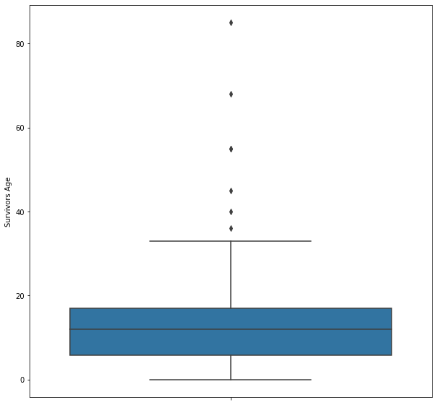

It was observed that the youngest girl abused was 6 years old and the oldest woman abused was aged 85 years old.

Fig 3.3.2

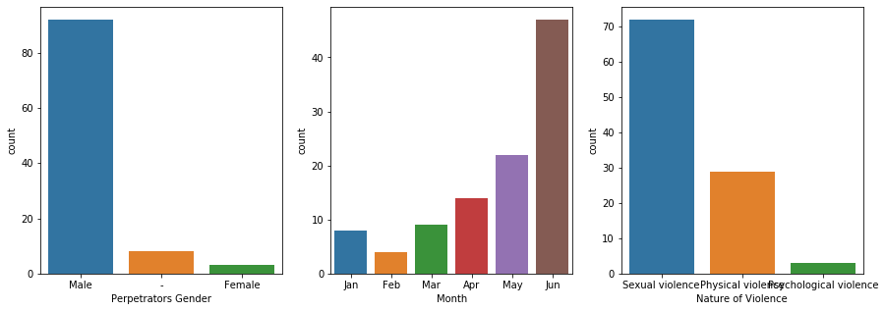

1. 92% of the perpetrator’s gender was male while 3% were female69% of the Violence was Sexual Violence, 28% of violence was Physical Violence, while 3% of the violence was Psychological violence.
2. Violence / Sexual Abuse is the highest during the Rainy Season of the Year 2020(April to June), this accounts for 81% of the reported cases.
3. 69% of the Violence was Sexual Violence, 28% of violence was Physical Violence, while 3% of the violence was Psychological violence.

Fig 3.3.3

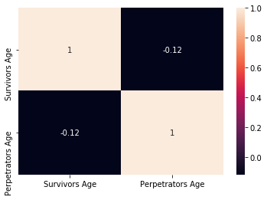

37% of perpetrator's ages were undeclared. The 63% that were declared imply the likelihood that more survivors knew their perpetrators. On the other hand, 15% of Survivors did not declare their age. The main age cluster for Survivors spans from as tender as 2 years old up until 20 years old. Painfully extreme survivors were as young as 3 and 6-month-old babies. However, for this cluster, their corresponding perpetrators were either at least 16 years to 45 years or 50 - 70 years old.

Fig 3.3.4

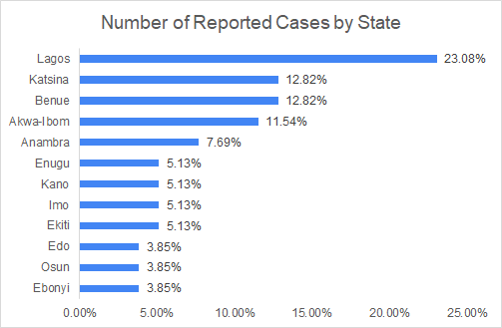

29 States out of 36 states in Nigeria were recorded, and it was observed that Lagos State had the highest reported cases which accounted for 23.% of the cases, while Benue and Katsina had 13% of the cases respectively.

Fig 3.3.5

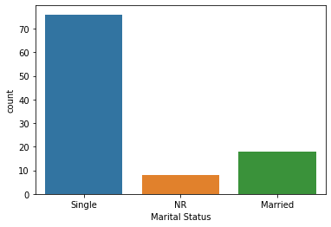

Again, from our analysis, it can be observed that 76% of the survivors are single while 18% of them are married.

## **3.4 Chapter Summary**

Violence against women especially in Africa is highly pervasive and incorrigibly ignored. A huge form of human rights violation. It is also a profound health problem that saps women’s energy, compromises their physical and mental health, and erodes their self-esteem. This is coupled with causing injury. Violence increases women’s long-term risk of several other health problems, including chronic pain, physical disability, drug and alcohol abuse, and depression to mention but a few

From research, an alarming number of women and girls who have a history of physical or sexual abuse are also at increased risk for unintended pregnancy, sexually transmitted infections, and miscarriages. Statistics as shown that men top the list in the record of sexual violence against women but reported cases as many cases that even go UN-Report (NR).

Our Data analysis has shown that the statistics of women abuse are huge in comparison to men. Analysis shows that 92% of the Perpetrators were males, 3% of the Perpetrators were females and 7% of the perpetrators were not recorded.

For some men, age is not a barrier to be an abuser or a perpetrator, It was observed that the youngest girl abused was 6 years old and the oldest woman abused was aged 85 years old. While the Perpetrator’s age ranged from 15 years as the least age to 75 years as the maximum age.

Our Analysis also shows that being married does not prevent some perpetrators. From our analysis, it can be observed that 78% of the survivors are single while 18% are married

Covid -19 lockdown saw an increase in recorded cases and Violence / Sexual Abuse is the highest during the Rainy Season of the Year 2020 (April to June), this accounts for 81% of the reported cases of violence against women. From the observations derived from our analysis, the SHE’RO mobile app is a timely intervention that must be encouraged and should be embraced by women for self-protection and availability for future datasets.

## 

## **Chapter 4**

## **4.1 Application & Reporting System Visualization & Process Breakdown**

This chapter covers the visual representation and description of the SHE’RO reporting system as well as the application, describing its functionality, process, and its validation. The validation has only been implemented on android devices and some functionalities are already deployed.

Based on our findings, we discovered very few women are aware of their rights, some are not clear about gender-based violence, while those who are aware of these rights find it difficult to report abuse cases. The app focuses on three (3) important areas:

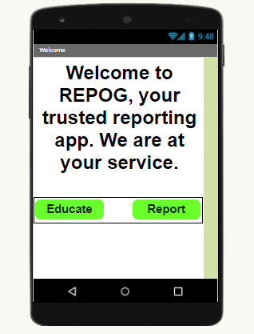

*Welcome/Landing App Page*

1. Educate: This is the functionality that enables women and girls to stay up to date with their rights, and describes in detail what GBV is and how to identify it. The report to our research and findings would also be uploaded here for downloads via the mobile app.
2. Security: With the Accelerometer Sensor embedded in the app, girls in distress can easily and immediately shake their phones and have an automated message sent alongside the location of the victim to a guardian, ward, or law enforcement personnel’s (especially in cases where the perpetrator is a warden or guardian).
3. Report: This is where individuals can report abuse cases, either as an eye-witness or as a victim. Reporters are free to report as Anonymous. With the sound and video recorder, cases can be reported with evidence to nail the culprit. Only the admin has full access to all the reported cases, these datasets would be used to further investigate GBV cases and also as real-time datasets for further research and app improvements. Data gotten over the app would be saved in a secure database and can be exported as a CSV file for Data Analysis.

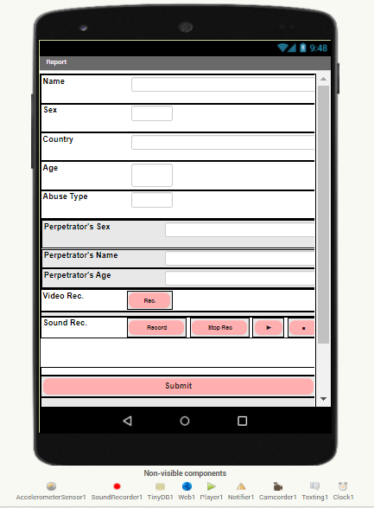

*The deployed reporting page*

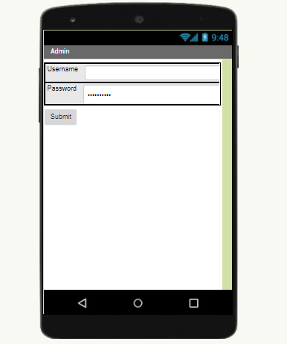

***Admin Access Point***

**Database:**

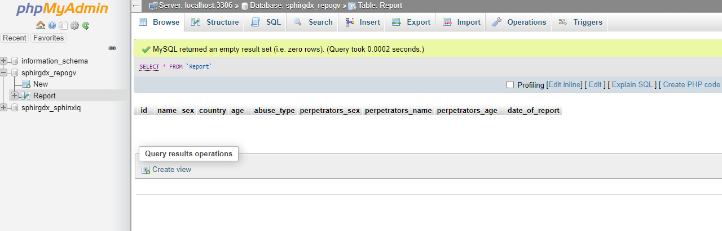

End Product: Open to further studies, our team is still working on making this a reality, first we came up with a better interface for our design. We used Figma to have a clear design on what the final product should be like.

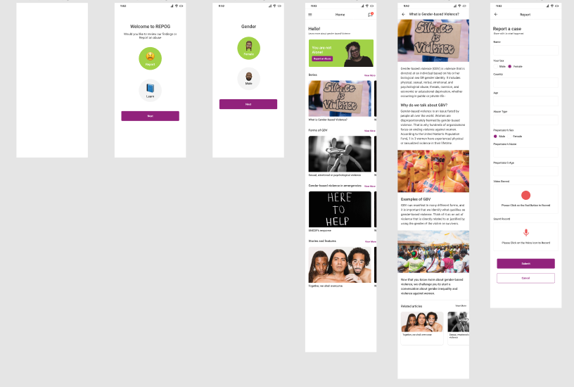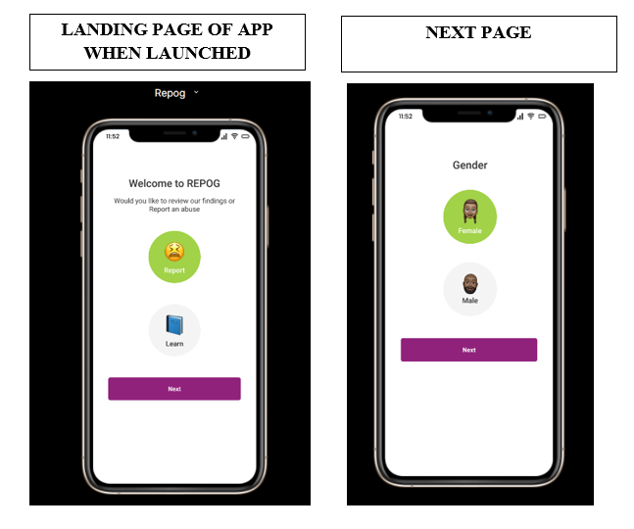

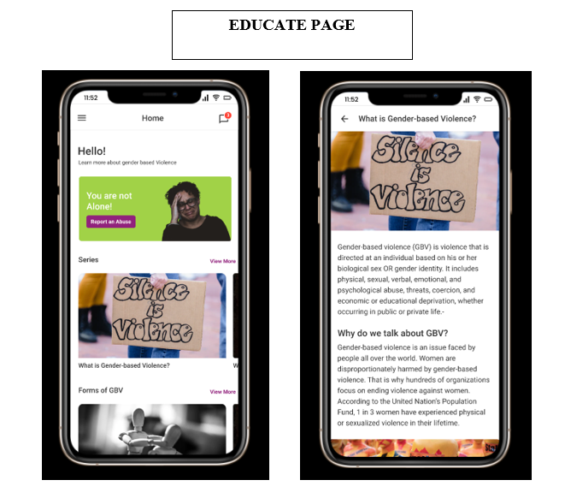

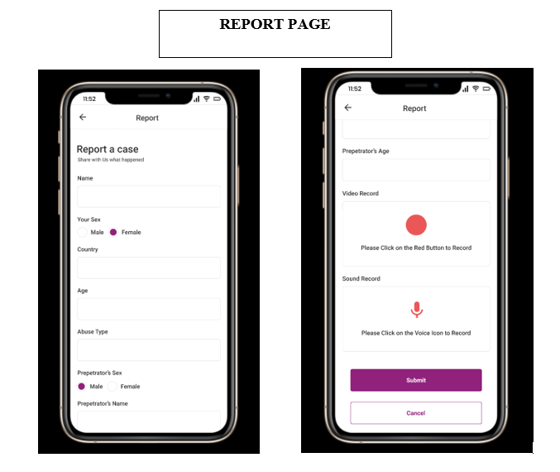

## **4.2 Significance of the Project**

The project captures technology providing solutions for social issues which is an area not exhausted by others so there's room for impact in that area, most importantly the project at its core aligns with United Nations Sustainable Development goals which make the project and the study even more relevant in our time also considering the line of research is zeroing in on current issues hence establishing relevance, there's room to make notable advances in this area.

## **4.3 Project Forecast**

This section seeks to narrate the plans of the project, and how the SHE’RO Team plans to progress; describe further support and tools or resources the SHE’RO project management team might need to execute the innovative idea

The SHE’RO team intends to expand research capacity as within the current timeline it was limited by the accessibility of data, we intend to contact NGOs related to women’s issues to sponsor us with related data to expound our analysis, we also intend to do primary research by issuing digital questionnaires and forms to gather data to further our progressive analysis. We also intend to make the project a reality by developing our app and reporting system hence we would request the support of the Women Techsters management with resources and manpower to bring the innovative idea to effect, we also hope to liaise with software developers, UX designers and brand management fellows from other tracks to improve on the details of our product. We intend to launch the product and make it available for use by December 2021 or earlier.

## **4.4 Recommendations**

* We recommend that women and girls are educated about their rights and how GBV could affect their health
* Schools should implement educating girls and boys about GBV and how it’s important to report GBV cases either as an eye witness or a victim
* We recommend that GBV cases shouldn’t focus so much on the victim and less on the perpetrator. The perpetrator should be published and posted as much as the victim is stigmatized.
* Recommend more safe spaces and groups for young women, and make young women the anchor/lead of these groups.
* We recommend that law enforcements dedicated to GBV are more active with how they go about bringing justice to victims. This would encourage more women to speak up about GBV issues.
* Recommend that psychologists or health care experts are the first point of contact for victims. Because most rape victims tend to have severe mental issues that most of them are not aware of.
* We recommend that ICT be used to capture perpetrators, by installing more CCTVs and launching more apps like ours to give on-the-spot response to GBV.
* We also recommend that everyone is registered to a database and mapped with a unique number, so after a case is reported, Artificial Intelligence can be used to catch the criminal with reduced investigation time.

## **4.5 Conclusions**

The marriage of technology and social science is a fitting bond, engaging in this study has been very fulfilling as we got to use the skills we have accumulated in the data science track for social impact; we look forward to doing more with what we have learned and getting opportunities to use programming and ICT to change lives and contribute even more greatly to the African and global welfare of women.

## **References**

The African Union Commission - Women, Gender and Development Directorate (AUC-WGDD) Roosevelt Street W21K19, Addis Ababa, Ethiopia P.O. Box 3243 Website: https://au.int/ Email: WGDD@africa-union.org

​

United Nations Entity for Gender Equality and the Empowerment of Women (UN Women), Liaison to AU and ECA Off Africa Road, UNDP Regional Service Centre 2nd Floor, next to Olympia Roundabout, Addis Ababa, Ethiopia P O Box 5580 Website: https://africa.unwomen.org/ Email: Tikikel.Tadele-Alemu@unwomen.org

​

Office of the United Nations High Commissioner for Human Rights (OHCHR), The Regional Office for East Africa New ECA Building Room 1N16, Addis Ababa, Ethiopia P.O. Box 3001 Website: https://www.ohchr.org/ Email: flurina.frei@un.org

​

United Nations Population Fund (UNFPA), Liaison Office to the AUC and ECA UNECA Compound, Congo Building, 5th Floor, Menelik II Avenue, Addis Ababa, Ethiopia P.O. Box 5580 Website: https://www.unfpa.org/ Email: ngonze@unfpa.org

UN-Women, The Shadow Pandemic: Violence against women during COVID-19. (2020).https://www.unwomen.org/en/news/in-focus/in-focus-gender-equality-in-covid-19-response/violence-against-women-during-covid-19.www.unwomen.org

· Hayley Boxall, Anthony Morgan, and Rick Brown January 2020. Australia.

· Morton, Nancarrow, Pfitzner, Fitz-Gibbon & True. 2020.

· Statistical Bulletin 28, Institute of Criminology 2. Australian.

· Delaney, Morton, Nancarrow, Payne, Morgan & Piquero. 2020.

· ABS, 2017.

· Fitz-Gibbon & Meyer. 2020.

· Pfitzner, FitzGibbon & True. 2020.

· Africa Union, 2020.

· UNFPA, March 30th, 2020.

**Appendices**

In this section find the systematic breakdown of the extra information regarding the project. Links to the entire data set used excel pivot tables etc. Appendices documents not attached here will be labeled and attached in a separate file as Appendix 1.a, 1.b, 1.c respectively.

**Appendix 1.a Chapter 3 Continuation Data Presentation**

Fig

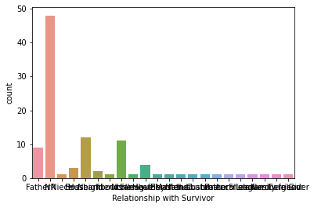

It was also observed that 48% of the perpetrator's relationship with a survivor was not reported, 11% of the perpetrators had no relationship with the survivors while the remaining 41% had a relationship with the survivor

Fig 3.3.7

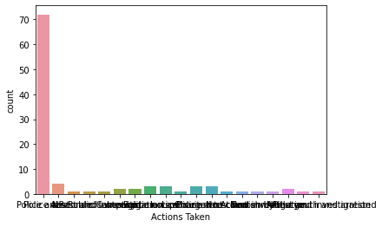

From our analysis, it can be observed that out of the 104 cases reported, 72% of the perpetrators have been arrested while the remaining 28% wasn’t identified.

* **Appendix 1.b Jupyter Notebook Data analytics**
* **Appendix 1.2.b Cleaned data set for jupyter notebook analytics**
* **Appendix 1.c Excel File: Data Set Analysis(Pivot tables & Charts)**
* **software app & database attachments (repog.apk, repogcsv, submit repo, update report)**
* **GitHub link to the repo: https://github.com/Women-Techsters-Fellowship-2021/SHE-RO-PROJECT-Grp8.git**

.

## **Team**

* Munenyashaishe Hove (Project Manager/Team Lead)
* Chinenye Vivian (Software development Lead)
* Choice Iruh (Data Analytics/Research Lead)
* Ibilolia Akahome
* Funmilayo Aina
* Mercy Oluwayotin
* Okoro Uchenna
* Fatimo Ajiboye
* Amarachi Ugagbe